**PRACTICAL 6**

**AIM:** Write and test a program to select the number of students who have scored more than 60 in any one subject (or all subjects).

**CODE:**

package p6;

import java.io.FileInputStream;

import java.io.FileOutputStream;

import jxl.Sheet;

import jxl.Workbook;

import jxl.write.Label;

import jxl.write.WritableSheet;

import jxl.write.WritableWorkbook;

import org.testng.annotations.BeforeClass;

import org.testng.annotations.Test;

public class c6

{

@BeforeClass

public void f1(){}

@Test

public void testImportexport1()throws Exception

{

FileInputStream fi=new FileInputStream("E:\\st\\excel\\sampledata.xls");

Workbook w=Workbook.getWorkbook(fi);

Sheet s=w.getSheet(0);

String a[][]=new String[s.getRows()][s.getColumns()];

FileOutputStream fo=new FileOutputStream("E:\\st\\excel\\result.xls");

WritableWorkbook wwb=Workbook.createWorkbook(fo);

WritableSheet ws=wwb.createSheet("result1",0);

int c=0;

for(int i=0;i<s.getRows();i++)

{

for(int j=0;j<s.getColumns();j++)

{

if(i>=1)

{

String b=new String();

b=s.getCell(3,i).getContents();

int x=Integer.parseInt(b);

if(x<60)

{

c++;

break;

}

}

a[i][j]=s.getCell(j,i).getContents();

Label l2=new Label(j,i-c,a[i][j]);

ws.addCell(l2);

}

}

wwb.write();

wwb.close();

}

}

**INPUT FILE(sampledata.xsl):**

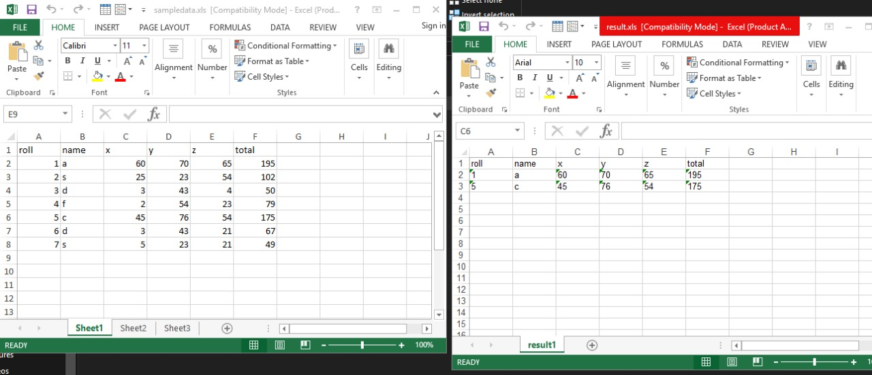

**OUTPUT FILE(result.xsl):**

